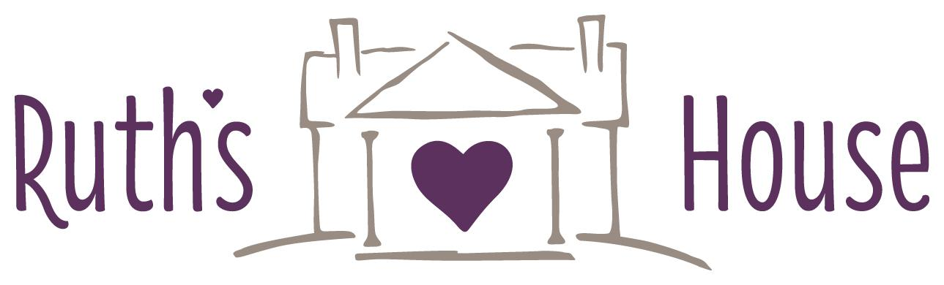

DONATION POLICY & GUIDELINES
Thank you for choosing Ruth’s House of Hope to receive your donations! Ruth’s House can accept furniture and other household items as donations. These donations help us achieve our mission:
Empowering lives, offering hope through transitional housing and support
OVERVIEW: All donations may be dropped off at Ruth’s House shelter. Please email giveruth@gmail.com to have your items approved BEFORE dropping them off. All furniture donations must be scheduled in advance. In addition to the items listed below, we accept items on our current Needs List, which is published in the newspaper, on our website at ruthshousemn.org and on our facebook page at facebook.com/ruthshouseofhope.
Donation drop-off hours at the Ruth’s House Shelter are: Tuesdays 1-4pm and Saturdays 12-2pm.
CLOTHING DONATIONS: Thank you for thinking of the families at Ruth’s House! Due to space constraints we cannot accept unsolicited clothing donations.
FURNITURE DONATIONS: Please email giveruth@gmail.com to inquire about all furniture donation.
- Furniture donations are accepted depending on current storage and enrolled families’ needs.
- All donation items must be delivered by the donor; pick-ups are not available.
- All items must be in new or gently used condition. We cannot accept any recalled furniture.

Furniture Items We Can Accept
- Small furniture
- Dressers
- Tables and end tables
- Couches/chairs (cleaned and in good condition)
Furniture Items We Cannot Accept
- Mattresses
- Headboards
- Office furniture
- Entertainment centers
- Cribs
- Washers & Dryers

HOUSEHOLD ITEMS AND OTHER DONATIONS: Household items and other donations should be functional and in good working condition. Bedding should be in new or gently used condition.

Household Items We Can Accept
- Laundry detergent
- Cleaners
- Toilet Paper
- Tissues
- Paper Towels
- Twin size bedding
- Twin size mattress protectors
- New pillows
Household Items We Cannot Accept
- Books
- Car seats/booster seats
- TVs (only upon request)
- Baby items
- Cell phones & electronics
- Computer monitors & equipment
- Printers & cartridges
*All donations made to Ruth’s House will be used primarily to meet the needs of our clients. Should any items be unsuitable for use by our clients, Ruth’s House reserves the right to use items at the agency’s discretion.

