 |  | 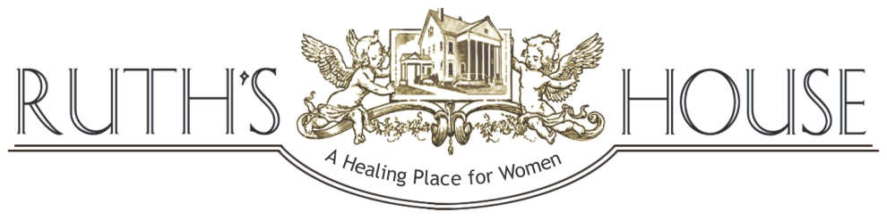
 |  | SPRING 2016 NEWSLETTER
SPRING IS A TIME OF CLEANSING AND RENEWAL
When spring arrives we clear the cobwebs and clutter from our minds, bodies and spirits (and our homes!).
The freshly opened space can then be filled with new experiences, new life, joy and hope. At Ruth’s House, this is the
process we engage in with our residents year round. Cleansing, letting go of the old, and creating space for the new.

Did you know that approximately 99% of Ruth’s House adult residents have experienced abuse? This seems unbelievable, but sadly it is true. Behind this statistic are the dozens of women that we serve each year at Ruth’s House, women with names and faces and their own life stories, almost all of them victims of domestic violence, childhood abuse, and/or sexual or emotional abuse.  The fallout of experiencing violence, especially violence during youth, can be disastrous. In adulthood, victims of abuse are more susceptible to substance abuse, mental illness and low self-esteem, all of which can lead to homelessness. |  |  | The work of Ruth’s House is so critical because we are providing women with opportunities they may never have been given. Yes, we provide shelter and basic needs, but above and beyond that, we offer support, care, understanding, respect, and the opportunity and encouragement to heal and move forward with new skills.  This is truly the special gift of Ruth’s House. With your support of Ruth’s House, you are helping women and children who, perhaps have never before experienced kindness or a helping hand. | YOU HAVE THE POWER  TO CHANGE LIVES!
- 90% of Ruth’s House clients experienced domestic violence
- 34% of clients experienced substance abuse
- 39% of clients had diagnosed disabilities
(2015 Stats)
RUTH’S HOUSE SERVICES TO PROMOTE HEALING FROM ABUSE AND TRAUMA

- Providing stability, including safe shelter and basic needs
- Weekly Women’s Empowerment Group
- Weekly individualized, strengths-based case management
- Weekly parent-child class
- 24-hour support from caring, supportive staff
- Referrals to the HOPE Center, counseling services and other agencies

RUTH’S HOUSE 2015 STATISTICS
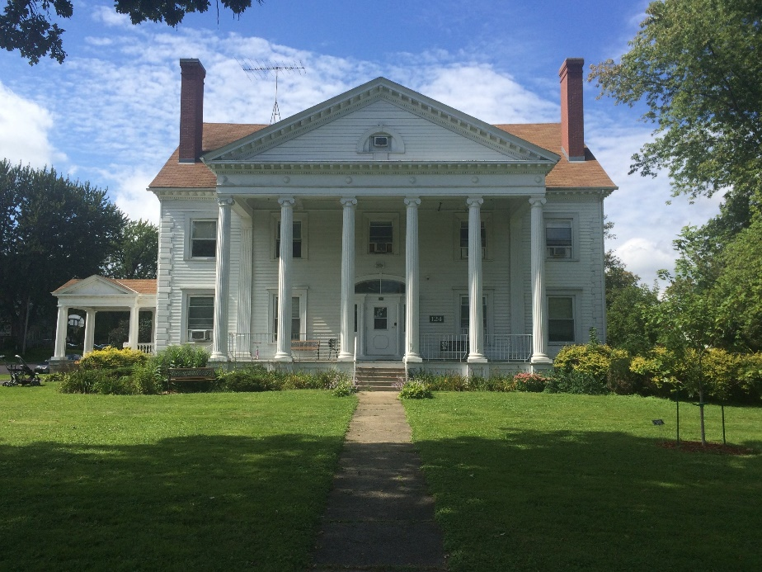 | Total Number Served by Program:  Transitional Shelter—110  Off-Campus Supportive Housing—33  Individuals Served:  Total Number—143  Adults—65  Children—78  Racial Background:  White—53%  Black/African-American—30%  American Indian or Alaska Native—3%  Multiple Races—14%  Average Length of Stay:  Transitional Shelter—3 to 6 months  Off-Campus Supportive Housing—1095 days (3 years)  "Nobody can go back and  start a new beginning, but  anyone can start today and  make a new ending."  Maria Robinson
Employment/ Education:
Twenty-two women, or 40%, obtained employment and/or returned to school during their stay at Ruth’s House. Of the remaining 33 women, 4 were awaiting legal status and could not legally obtain employment, 8 went into treatment for substance abuse, 10 were diagnosed with physical and/or mental disabilities that prevented employment, and 11 clients exited the Transitional Shelter within 3-10 days after arrival, due to varying circumstances.

Financial Donors |  |  |  | THANK YOU FOR MAKING THESE SERVICES POSSIBLE  Our deepest appreciation to the following supporters of Ruth’s House  who brought hope and help to 143 women and children in 2015  Financial Donors  In-Kind Donors  Grantors  Board of Directors  Ruth’s House Staff  Volunteers  Volunteers donated 4,000+ hours to Ruth’s House last year, the equivalent of two full-time staff!
Domestic Hunger Grant
 | Carlander Family
Northfield Area United Way
 | South Chapter
North Chapter
 |  |  | 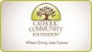

Donate Generously | Shop for Ruth’s House | Volunteer Some Time &TLC
Your contribution goes a long way at Ruth’s House, thanks to our careful budgeting!  The cost for one resident per day at the Transitional Shelter is only $20. This includes:  - Rent  - Household & personal needs  - Food  - 24 hour support  - Weekly one-on-one meeting with a trained Case Manager  - Two life skills programs weekly, facilitated by professionals (childcare included) | Ruth’s House Spring Needs  Paper towels  Bath tissue  Laundry soap (HE)  Vacuum cleaners  Kwik Trip gift cards  Aldi gift cards  New bed pillows  Twin mattress pads | HELP WANTED  PARTY PEOPLE NEEDED  Like Event Planning? Join our awesome Gala Committee. Help coordinate the Dessert Auction, Silent Auction or pitch in with whatever skills you have. First meeting May 2, 2016.  SEEKING DIGITAL STORYTELLER  Share your video making skills! Make a 90- second to 2-minute digital information video about Ruth’s House.  Contact Katie Cooper, Volunteer Coordinator: 507-334-5043 or  katiec.ruthshouse@gmail.com  Other volunteer opportunities are also available!
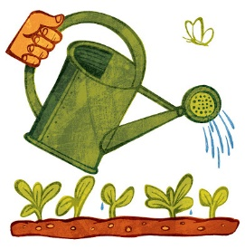

Three Ways YOU Can Plant Seeds of Hope at Ruth’s House

GOOD NEWS AT RUTH’S HOUSE
Healthy Activities at Ruth’s House in 2016 |  |  | 2016 Gala a Success
Ruth’s House was recently awarded a Neighborhood Health Connection grant for 2016 from the Allina Health System.  This grant will allow Ruth’s House residents to participate in 6-week sessions of healthy activities, including a walking group (adults and children) and healthy cooking classes. | In 2016 grants were awarded to 59 organizations in Minnesota and western Wisconsin to support activities that promote social connections and increases in healthy behavior. |  | Over $34,000 (including funds to replace our 50-year-old kitchen stove) was raised and another year of services at Ruth’s House made possible, thanks to generous community support of our mission! Special thanks to all those who attended the Gala, helped organize the event, or donated goods and services.  Save the Date: Saturday, February 11, 2017 |  | 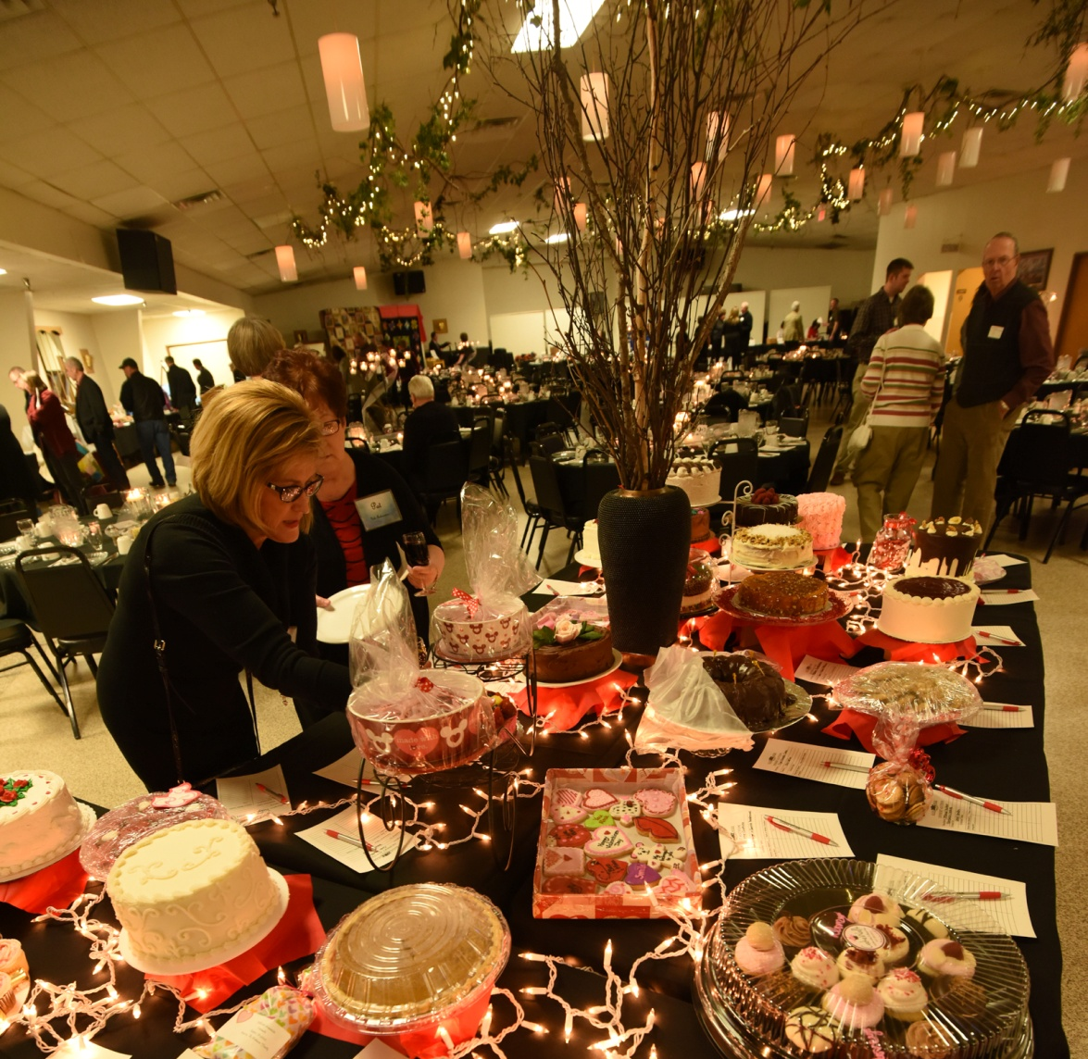
2016 Gala Committee: Joyce Elsen, Ruth Hildebrandt, Lynn Pohlman, Jeanne Ullian,
Chris Angell, Kari Boldt, Eva Gramse, Katy Erickson, Pat Johnson, Karen Nigon, Katie Cooper, Ruth Hickey, Kathy Tonolli, Angie Olson, and Kari Tobin
New Ruth’s House Website
Neuger Communications in Northfield will be giving a
 |  |  | complimentary “spring cleaning” to our website and brochure! Keep an eye out for the new Ruth’s House website and updated materials. We are absolutely delighted with this project! Thanks so much to the generous Neuger team for donating your time and expert skills.

LIKE us on |  | www.facebook.com/Ruths-House-of-Hope-1727565584138730/ |  | Visit our website: ruthshousemn.org
Nonprofit Org.
U.S. Postage Paid Faribault, MN 55021
Permit No. 27.

219 Fourth Avenue NW
Faribault, MN 55021

Return Service Requested

Phone: 507-332-2236
Outreach Office: 507-334-5043
Fax: 507-334-2487
Email: ruthshouseofhope@yahoo.com

Not Only Shelter, Safety
Not Only Help, Hope
Not Only Change, Growth
Not Only a House, a Home

April is National Child Abuse Awareness Month

This month is symbolized by the pinwheel. Shining in the sun,
the pinwheel is reflective of the bright future all children deserve.

Children are my favorite people and they are the most vulnerable of residents at Ruth’s House Transitional Shelter.
My constant concern, and what I pray for always, is that the children who come with their moms to reside at Ruth’s House find safety in this sanctuary, away from unpleasant circumstances. My hope is for the children to flourish in a loving home, surrounded by caring, nurturing, positive role models, such as our dedicated staff and volunteers who “give their all” to the most vulnerable, day in and out. Lastly, I wish that all the children and their families will find the resources they need to live in a safe, healthy and permanent home.

Thank you to all who have contributed so much to the ministry of Ruth’s House and for helping these families transition and flourish in our community!

I ask you today to please remember the children, our most vulnerable neighbors, and prayerfully consider a donation. We need your help to raise $258,000 this year to operate the shelter. Thank you and may God bless you and your family!

With gratitude and faith,
Ruth Hickey
Executive Director

